Running head: GPU APPLICATIONS

Interesting Applications of the GPU

Central Washington University

Joshua.Martinez3@cwu.edu

Joshua Martinez

5/24/2021

Dr. Salter

CS 325

Contents

I-Abstract 2

I.1-Key words 3

II-Introduction 3

III-Narrative: 3

III.1-GPU vs CPU 4

III.2-Graphical Applications 5

III.2.A-shaders 5

III.2.B-Ray tracing 7

III.2.C-Video filtering 6

III.2.D-Fire simulation 8

III.3-Non-Graphical Applications 8

III.3.A-Compute shaders 8

III.3.B-Fluid Simulation 9

III.3.C-Visualizing the fourth dimension 9

III.3.D-Mining crypto-currency 9

IV-Conclusion 9

V-References: 10

VI-Appendix 11

Figure 1: Normal Minecraft (left) vs Minecraft with ray tracing (right). 8

Figure 2: How realistic fire is efficiently rendered. 8

Figure 3: Refraction: Normal Minecraft - left; Ray traced Minecraft - right.. 12

Figure 4: Normal maps and shadwos: Normal Minecraft - left; ray traced Minecraft - right. 12

Figure 5: A single frame of the Lattice Boltzmann Method of fluid simulation. 12

I-Abstract

While individual or specific applications of the graphics processing unit (GPU) are in no short supply, there are no sources which provide a use of the GPU from many different angles. There are GPU applications for a wide array of topics, so this is important to discuss. Considered applications are from 2008 to 2021. For any problem which works well with a divide and conquer technique, the GPU shines (Gaster & Howes, 2012). This is due to the GPU’s extreme parallelism (Che, Boyer, Meng, Tarjan, Sheaffer, & Skadron, 2008). The GPU can also provide significant increase in performance compared to the central processing unit (CPU) (Che et al., 2008). For one application of simulating fire, up to 50 times better performance could be recorded in the GPU compared to the CPU (Horvath & Geiger, 2009). The GPU has far surpassed its original purpose of colored text (Crow & Harris, 2004). Now uses can also be for shaders, physics simulations, complex math calculations, and cryptocurrencies.

## 

## I.1-Key words

CPU, 2, 3, 4, 5

divide and conquer, 2, 3, 9

fluid simulation, 2, 4, 9, 12

GPU, 1, 2, 3, 4, 5, 6, 7, 8, 9, 10, 11

Graphical, 2, 3, 5, 8, 11

LBM, 9, 10

parallelism, 2, 9

ray tracing, 2, 3, 4, 7, 11

rendering, 7, 8

shaders, 2, 3, 5, 6, 8, 9

threads, 4, 8, 10

# II-Introduction

Here will be covered *some* graphical and non-graphical,interesting applications of the graphics processing unit (GPU); to cover all applications of the GPU would be impossible. According to *Evolution of the Graphical Processing Unit*, the first video processing card was made by IBM in 1984 and it only supported non-color text (Crow & Harris, 2004). Today, to name a few examples, GPUs support 3D graphics, thousands of simultaneous small processes, and of course colored texts. Due to its name, there would be no fault to think the GPU is good for graphics only. While the GPU is very good with graphics: i.e., shaders and ray tracing, it also has many non-graphical applications: i.e., complex math, mining for money, and general performance upgrades over the central processing unit (CPU). In truth, most GPU applications include both graphical and non-graphical components, such as using math (non-graphical) to simulate a fire (graphical). Note: divide and conquer is a technique of dividing a process into similar smaller parts; all parts can be solved with the same algorithm. If a process can be divided into very simple parts with the divide and conquer technique, then that process can utilize the GPU. Finally, while interesting *individual* GPU applications are in no short supply, this paper is **useful** because it tries to convey a more general idea of what makes a GPU important. It is a hopefully good first step for those interested in the GPU, or a way to tether in those not interested in the GPU.

# III-Narrative:

Here will be discussed the interesting applications of the GPU. First the GPU performance, which will compare the CPU and GPU for various programs. Second: the (mostly) graphical uses of the GPU. This will include a discussion on vertex and fragment shaders. It will also include discussions on video filtering, ray tracing, and a fire simulation. Third: the (mostly) non-graphical uses of the GPU. This will include a discussion on compute shaders, fluid simulation, 4D to 3D visualization, and Mining crypto currency. Except for compute shaders (which is necessary to understand for its proceeding applications) application are organized from most graphical to least graphical.

## III.1-GPU vs CPU

GPUs have many threads: each thread is a section of a processor which completes one task at a time, which allows for large numbers of very small, but parallel tasks. While CPUs also have threads and thus also allow for parallel tasks, they do not allow for nearly as many. That being said, those tasks can be much more complex (Che et al, 2008). If the CPU were a person and was tasked with writing a seven paged paper, it could think of what to write, and, if it really pushed itself, could write that paper in 24 hours. If the GPU were a person, and received the same assignment, it would never be able to come up with an idea, nor would it know what to write even if given an idea. But when told exactly what to write, could then do so 100 times over in less than a second without breaking a sweat.

Pavel et al, created an experiment of testing the GPU and CPU comparatively for seven different problems. Here will be shown only two. In the experiment, they compare an NVIDIA GeForce GTX 260 GPU and two Intel-Xeon dual-core processor CPUs. They used the Cuda language for GPU applications—which is­­ an NVIDA created language designed for utilizing the GPU—and OpenMP API for the CPU. The same number of inputs is given for each version, and the timing of the program is calculated using commands within the code of either language. While it is true that the hardware used here is outdated, the tests themselves are represented in factors, not specific times. So, it should still be accurate for these specific applications.

The first test was with SRAD: a method for removing unnecessary visual noise in ultrasonic radar imaging. The technique divides itself into a square matrix and thus works well with a parallel implementation. In the end, the Cuda version had a 5x increase in speed over the CPU equivalent program when applying the program to a matrix of size 2,048 (4,194,304 elements).

The second test was with Combinational logic, specifically it seems permutations. This is an interesting example because it was tested in two different ways: firstly, using if-statements, and secondly, using look-up tables. Look-up tables require much less “thinking” from the program. An if-statement would be like being told to go to a certain chapter in a book (without using the TOC), and a look-up table would be like being told to go to specific page number. In the end, with a permutation of 64, it was found that the look-up table had a 2.6 to 5.5 factor of increase in speed compared to if statements (for a GPU implementation). This shows that the GPU works much better when it does not have to “think.” Now only using look-up tables and an input size of 18, it was found that the GPU had a 12x increase in speed over the CPU.

## III.2-Graphical Applications

Like previously stated, many GPU applications have at least a little of both graphical and non-graphical components. This seems especially true for graphical GPU applications.

### III.2.A-shaders

Shaders are programs written to have (usually) visual effects in a program like OpenGL or Vulkan. This can range from making a tree’s leaves rustling in the wind in some video game engine to having neat patterns float around in the background of some GUI. Every shader takes an input and gives an output to the next part of the graphics pipeline: first in the pipeline is the Vertex shader: it takes in information about a 3D object and modifies it. The vertex shader then hands its output to the next set of steps in the pipeline (which goes beyond the scope of this paper), until it reaches the fragment shader. The fragment shader is the last part of the pipeline: it colors in the pixels on the screen. Here you have seen two major shaders: Vertex and Fragment. Another major shader is the compute shader. (Bailey & Cunningham, 2012) This will be discussed in section III.3.

Vertex shaders: Most importantly the vertex shader takes in vertex location (in x, y, z coordinates) and their normals: the angle the vertex is pointing. Assuming that proper shading has already been implemented, normals also dictate the shadows on the object; the closer two normal angles are to each other are, the smoother a shadow will be. The vertex shader can modify these values in real time (per vertex of a 3D object), and then output them to the rest of the graphics pipeline. For example, a static sharp-edged sphere could be inputted, and outputted: a smooth-edged cube with 3D waves going up and down its surface displaced 25 units away on the x-axis. (Bailey & Cunningham, 2012)

Fragment shaders: In short, they produce a color for every pixel on the screen. For a common 1080 by 1920 monitor, that is 2,073,600 pixels to color. If you have a 60hz screen, that is 124,416,000 pixels to color *per second*. This is on top of whatever complicated math or background functions the GPU might already be doing. With these types of numbers, the GPU starts to seem impressive. Most importantly, a fragment shader takes in a texture: a 2D colored “wrap” which is “glued” perfectly onto an object. For example, when you wrap a present, it is kind of like you are giving it a texture. In real time, the fragment shader can modify this texture. This is where tasks like reflections on a window, or transparencies and different shades of orange in a fire are implemented. To name a few methods, these colors can be based off some function using time as a variable, a texture, an object’s geometry, or its coordinates in 3D space.

### III.2.B-Video filtering

One use of the GPU is video filtering. For example, giving a video a blue tint, or negating it.

Video filtering using the GPU is beneficial because it uses much less memory (Wijayanti & Alfironi & Wibirama & Bejo, 2019).

A Wijayanti et al conducted a study in 2019 comparing OpenCV and openGL (both languages utilizing the GPU) for video filtering. It was found that OpenGL was more efficient and took less memory. Here, how the filtering is executed with OpenGL will be considered. There are five main steps: extracting, decoding, editing, encoding, and mixing. *Extraction*: Separates video into audio and visual. *Decoding:* the video is divided into a group of frames. *Editing*: the specified filter is applied to all frames. *Encoding*:the frames are combined into a video. This is a process that takes place inside of the graphics pipeline discussed in III.2.A.

### III.2.C-Ray tracing

On a high level, ray tracing is an accurate simulation of light (i.e. reflections, refractions and accurate shadows) by recursively following a path into the virtual scene for each pixel on your screen. All those paths bounce around on geometry in the scene until either a predefined max bounce limit has been met, or the paths hit a light source. Data about how light hits the geometry (or how it doesn’t) is returned to the pixel and a color is outputted to the screen. (Park & Baek, 2021)

There are many real-time ray tracing engines out now. They utilize NVIDIA’s new RTX series of GPU, which is a set of GPUs all specially built for ray tracing; their architecture will not be discussed here. This does not mean that ray tracing was impossible beforehand, but it was not possible in *real-time*. Rendering a single frame in blender (a 3D modeling/rendering program) could take anywhere from 30 seconds to 2 hours depending on your hardware and the complexity of your shot. With the RTX series, you can render anywhere from 1 to 120 to an unbounded number of frames all in one second.

Figure 1 shows the potential power of ray tracing in Minecraft. Two pictures were taken in the same spot, and near the same time (10 second difference at most). The image on the left shows Minecraft with no ray tracing, and the image on the right shows Minecraft with ray tracing. Notice how on the right, the lava is casting light and shadows, and the water is reflecting like real water.

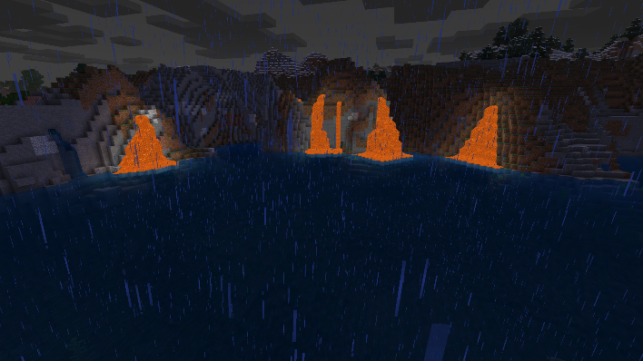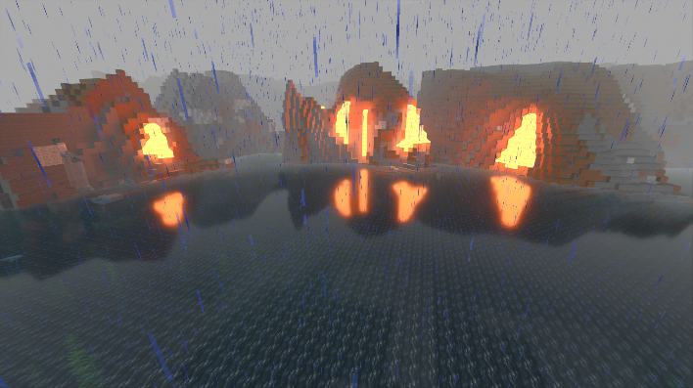

Figure 1: Normal Minecraft (left) vs Minecraft with ray tracing (right).

In the appendix, there are closer examples of refractions (Figure 3); normal maps (Figure 4): a mix between a texture and a normal which allows a flat object to look 3D; and detailed shadows (Figure 4).

### III.2.D-Fire simulation

If anything exemplifies the mixing of graphical and non-graphical GPU use, it is fluid simulations like fire. Here, the graphical half will be discussed. While simulating an entire hyper-realistic fire in real time is still too complex for computers today, it is completely possible to take hours (or days) rendering the fire one frame at a time. Rendering the entire fire, however, is not necessary. Horvath and Geiger (2008) instead split the fire into spaced out sections, and then render each section in parallel as an image (all using the GPU). When the images are placed near each other, the fire looks hyper realistic and 3D from intended angles. This entire process is an example of Divide-and-Conquer (on top of simplification by rendering in *spaced out* sections) and is displayed in figure 2.

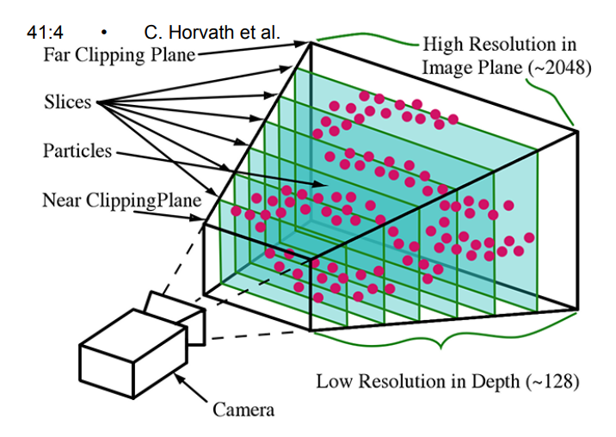



Fire particles



Figure 2: How realistic fire is efficiently rendered.

Source: Horvath, C. & Geiger, W. (2009). Directable, high-resolution simulation of fire on the GPU. ACM Transactions of Graphics, 28(3)

## III.3-Non-Graphical Applications

### III.3.A-Compute shaders

Like vertex and fragment shaders, compute shaders are designed to split up the work among the GPUs threads (Delgado-Gutierrez, Marzocca, & Cardenas, 2020). What makes compute shaders useful for non-graphical applications is that they have no defined input or output. Anything can be inputted, and anything can be outputted.

### III.3.B-Fluid Simulation

Delgado-Gutierrez et al (2020) devised an improvement for using the Lattice Boltzmann Method (LBM): a mathematical method of fluid simulation which lends itself to parallelism, and being divided into very small, simple sections called particles (divide and conquer). More detailed fluids require more particles. The LBM math tells each particle where to move: the particle’s motion is slightly randomized, so it feels more organic; all particles together then look like fluid. In the experiment, compute shaders take in a texture, compute the LBM calculations based on the texture, and then output the particle location. A 2D LBM simulation method, while not Delgado-Gutierrez’s et al, is exemplified with this link: <https://www.shadertoy.com/view/WdyGzy> (Figure 5, in the appendix, shows a single frame). This is considered a non-graphical use of the GPU because of what is most important in this application: performing the math for the particles. Outputting the fluid onto a screen is not the intensive process here.

### III.3.C-Visualizaing the fourth dimension

Ohori, Ledoux, and Stoter created a program which visualizes 4D objects in 3D (2017). To do this, they used compute shaders. A 4D matrix is inputted into the shader, and then math which exceeds this paper’s purpose is used to convert to a 3D matrix. The 3D matrix is then printed as a 3D object onto the screen. Not only is visualizing a 4D object in 3D useful for better understanding 4D objects, but more importantly, this process creates an easier computation for visualizing large 3D models such as cities or forests.

### III.3.D-Mining crypto-currency

Pavel, Dmitry, and Maxim (2019) attempted to increase efficiency of mining crypto currency. In short, they made some improvements on the speed of transactions. The primary discussion here is how the mining utilizes the GPU.

Pavel et al use OpenCL (2019), which uses compute shaders. To earn cryptocurrency, you must dig through hashes on servers. Once you have a hash, you must “break it open” with mathematical calculations (Pavel et al, 2019). The Hash may or may not have cryptocurrency. It is not stated in the article, but it can be assumed that threads divide up the hash calculations. Parallel after all what makes the GPU special.

# IV-Conclusion

GPUs can do many parallel tasks, so long as they are easy tasks. Despite its name, GPUs often perform non-graphical tasks even for graphical applications; this is especially exemplified in the LBM method, where parallel math is used to visually simulate water. One Avenue that the GPU has scarcely explored is music. Using all of the discussed applications, it seems likely that the GPU can only have positive effects on music whether that be in how it sounds, or in how efficiently it can be digitally created (or both).

# V-References:

Bailey, M. & Cunningham, S. (2012). *Graphics Shaders Theory and Practice: Second Edition*. Boca Raton, Florida: CRC Press

Che, S., Boyer, M., Meng, J., Tarjan, D., Sheaffer, J. W., & Skadron, K. (2008). *A performance study of general-purpose applications on graphics processors using Cuda*. Journal of Parallel and Distributed Computing, 68(10), 1370–1380

Crow, T. S. & Harris, F. C. (2004). *Evolution of the Graphical Processing Unit*. Reno, Nevada: University of Nevada

Delgado-Gutlierrez, A., Marzocca, P., Cardenas, D., & Probst, O.(2020). *A highly accurate GPU Lattice Boltzmann method with directional interpolation for the probability distribution functions*. International Journal for Numerical Methods in Fluids, 92(12), 1778–1797

Gaster, B. R., Howes, L., Kaeli, D., Mistry, P., & Schaa, D. (2012). *Heterogeneous Computing with OpenCL*. Waltham, Massachusetts: Elsevier

Horvath, C. & Geiger, W. (2009). *Directable, high-resolution simulation of fire on the GPU*. ACM Transactions of Graphics, 28(3)

Ohori,K.A., Ledoux,H., & Stoter,J.(2017). *Visualising higher-dimensional space-time and space-scale objects as projections to R3*. PeerJ Computer Science

Pavel, S. V., Dmitry, S. S., & Maxim, S. O. (2019). *Determining optimal mining work size on the openCL platform for Ethereum Cryptocurrency*. International Journal on advanced science, engineering and information technology, 9(5), 1528–1554

Park, S. & Baek, N. (2021). *A shader-based ray tracing engine*. Applied Sciences, 11(7)

Wijayanti, S., Alfironi, B., Wibirama, S., & Bejo, A. (2019). *A new native video filtering based on OpenGL ES for mobile platform*. International Journal on Advanced Science Engineering Information Technology,9(3), 759–765

# VI-Appendix

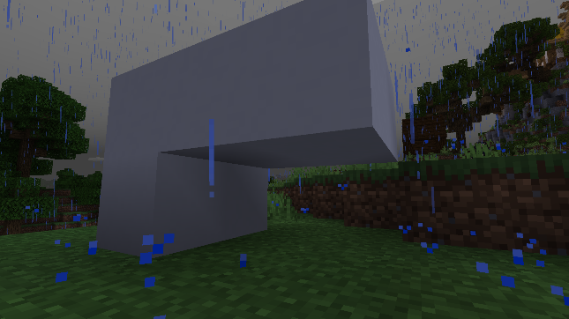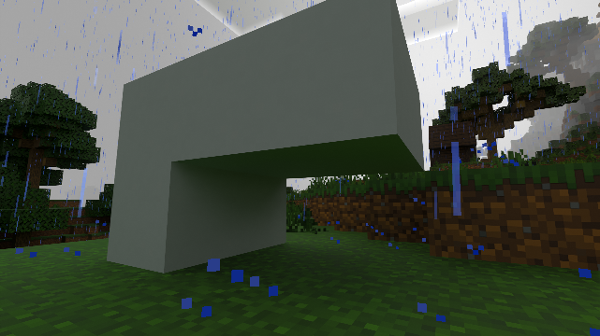

Figure 3: Normal Minecraft - left; Ray traced Minecraft - right. Notice how on the right, the white structure has a tint of green on its bottom. This is light being reflected from the grass; otherwise known as refraction.

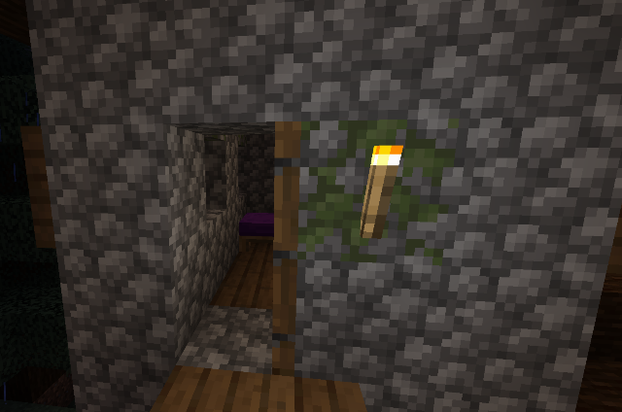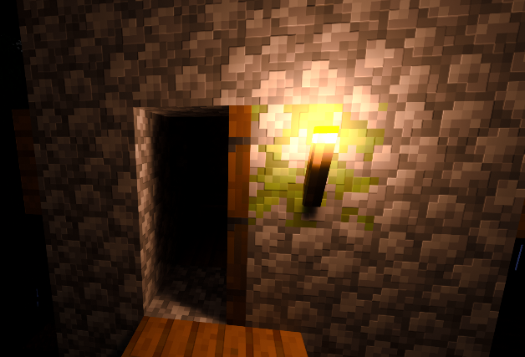

Figure 4: Normal Minecraft - left; ray traced Minecraft - right. If you look closely at the stone wall in the right image, you will notice some stones have small shadows. They are regardless flat. This is an example of a normal map.

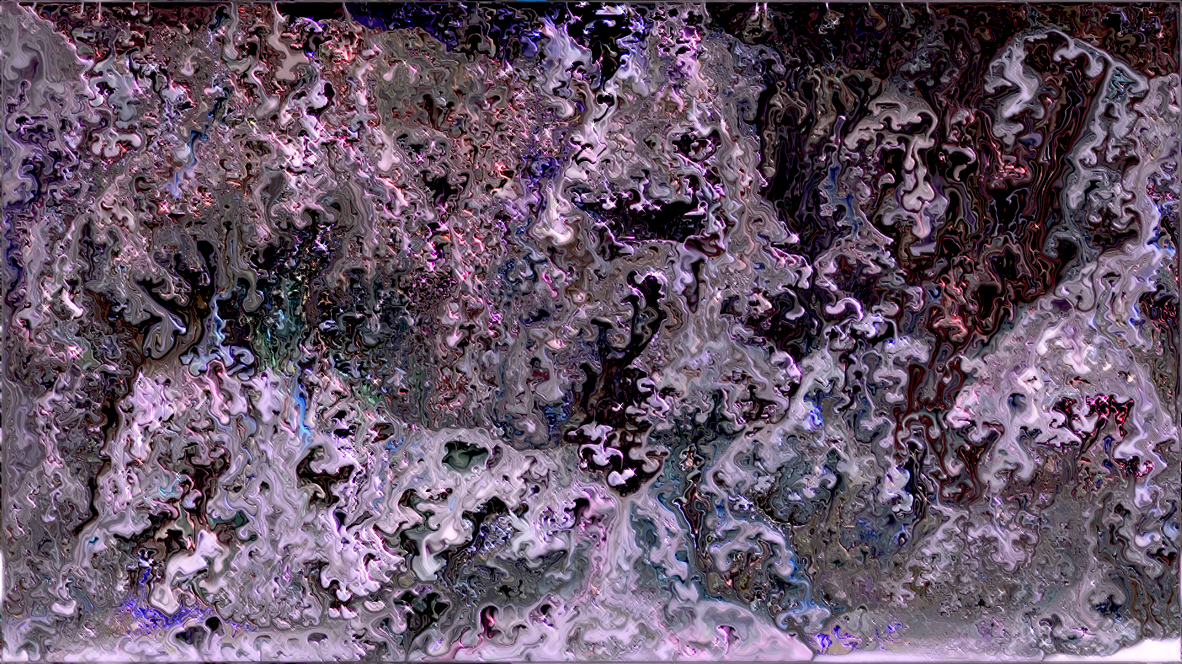

Figure 5: A single frame of the Lattice Boltzmann Method of fluid simulation. The full source is much cooler.

Source: https://www.shadertoy.com/view/WdyGzy